T H E O R E T I C A L P R O B L E M S

Problem 1
The figure 1.1 shows a solid, homogeneous ball radius R. Before falling to the floor its center of mass is at rest, but the ball is spinning with angular velocity ω₀ about a horizontal axis through its center. The lowest point of the ball is at a height h above the floor.

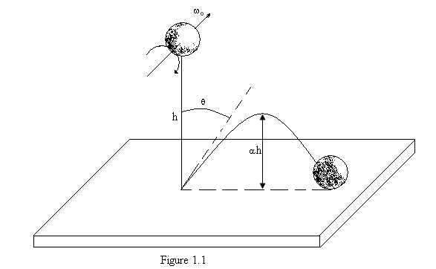
When released, the ball falls under gravity, and rebounds to a new height such that its lowest point is now ah above the floor. The deformation of the ball and the floor on impact may be considered negligible. Ignore the presence of the air. The impact time, although, is finite.

The mass of the ball is m, the acceleration due the gravity is g, the dynamic coefficient of friction between the ball and the floor is μ_{k}, and the moment of inertia of the ball about the given axis is:
I = 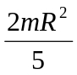
You are required to consider two situations, in the first, the ball slips during the entire impact time, and in the second the slipping stops before the end of the impact time.

Situation I: slipping throughout the impact.
Find:
- tan θ , where θ is the rebound angle indicated in the diagram;
- the horizontal distance traveled in flight between the first and second impacts;
- the minimum value of ω₀ for this situations.

Situation II: slipping for part of the impacts.
Find, again:
- tan θ;
- the horizontal distance traveled in flight between the first and second impacts.
Taking both of the above situations into account, sketch the variation of tan θ with ω_{0.}

Problem 2
In a square loop with a side length L, a large number of balls of negligible radius and each with a charge q are moving at a speed u with a constant separation a between them, as seen from a frame of reference that is fixed with respect to the loop. The balls are arranged on the loop like the beads on a necklace, L being much greater than a, as indicated in the figure 2.1. The no conducting wire forming
the loop has a homogeneous charge density per unit length in the in the frame of the loop. Its total charge is equal and opposite to the total charge of the balls in that frame.
Consider the situation in which the loop moves with velocity v parallel to its side AB (fig. 2.1) through a homogeneous electric field of strength E which is perpendicular to the loop velocity and makes an angle θ with the plane of the loop.

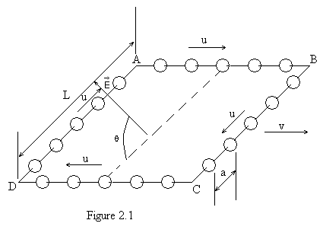
Taking into account relativistic effects, calculate the following magnitudes in the frame of reference of an observer who sees the loop moving with velocity v:
- The spacing between the balls on each of the side of the loop, a_{AB} , a_{BC} , a_{CD} , y a_{DA}.
- The value of the net charge of the loop plus balls on each of the side of the loop: Q_{AB ,} Q_{BC ,} Q_{CD} y, Q_{DA}
- The modulus M of the electrically produced torque tending to rotate the system of the loop and the balls.
- The energy W due to the interaction of the system, consisting of the loop and the balls with the electric field.
All the answers should be given in terms of quantities specified in the problem.
Note. The electric charge of an isolated object is independent of the frame of reference in which the measurements takes place. Any electromagnetic radiation effects should be ignored.

Some formulae of special relativity

Consider a reference frame S’ moving with velocity V with reference to another reference frame S. The axes of the frames are parallel, and their origins coincide a t = 0. V is directed along the positive direction of the x axis.

Relativistic sum of velocities

If a particle is moving with velocity u’ in the x’ direction , as measured in S’, the velocity of the particle measured in S is given by:
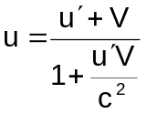
Relativistic Contraction

If an object at rest in frame S has length L₀ in the x-direction, an observer in frame S’ (moving at velocity V in the x-direction} will measure its length to be:

L =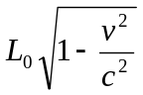

Problem 3 Cooling Atoms by laser
To study the properties of isolated atoms with a high degree of precision they must be kept almost at rest for a length of time. A method has recently been developed to do this. It is called “laser cooling” and is illustrated by the problem below.

In a vacuum chamber a well collimated beam of Na²³ atoms (coming from the evaporation of a sample at 10³ K) is illuminated head-on with a high intensity laser beam (fig. 3.1). The frequency of laser is chosen so there will be resonant absorption of a photon by those atoms whose velocity is v_{0.} When the light is absorbed, these atoms are exited to the first energy level, which has a mean value E above the ground state and uncertainty of Γ (fig. 3.2).

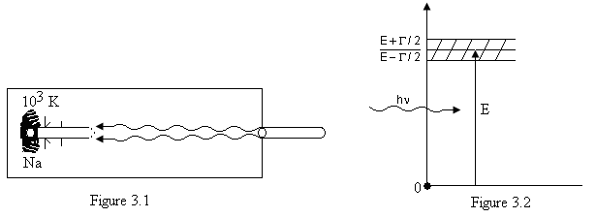
For this process, the atom’s decrease in velocity Δv₁ is given by Δv₁ = v₁ – v₀. Light is then emitted by the atom as it returns to its ground state. The atom’s velocity changes by Δv’ = v’₁ – v₁ and its direction of motion changes by an angle ϕ (fig. 3.3).

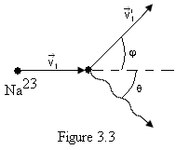

This sequence of absorption and emission takes place many times until the velocity of the atoms has decreased by a given amount Δv such that resonant absorption of light at frequency v no longer occurs. It is then necessary to change the frequency of laser so as to maintain resonant absorption. The atoms moving at the new velocity are further slowed down until some of them have a velocity close to zero.

As first approximation we may ignore any atomic interaction processes apart from the spontaneous absorption and emission light described above.
Furthermore, we may assume the laser to be so intense that the atoms spend practically no time in the ground state.

Questions

- Find the laser frequency needed ensure the resonant absorption of the light by those atoms whose kinetic energy of the atoms inside the region behind the collimator. Also find the reduction in the velocity of these atoms, Δv₁, after the absorption process.

- Light of the frequency calculated in question a) is absorbed by atoms which velocities lie within a range Δv₀. Calculate this velocity range.
- When an atom emits light, its direction of motion changes by ϕ from initial direction. Calculate ϕ.
- Find the maximum possible velocity decrease Δv for a given frequency.
- What is the approximate number N of absorption-emission events necessary to reduce the velocity of an atom from is initial value v_{o}
-found in question a) above- almost to zero? Assume the atom travels in a straight line.
f)Find the time t that the process in question e takes. Calculate the distance ΔS an atom travels in this time.
Data
E = 3,36⋅10⁻¹⁹ J
Γ = 7,0⋅10⁻²⁷ J
c = 3⋅10⁸ ms⁻¹
m_{p} = 1,67⋅10⁻²⁷ kg
h = 6,62⋅10⁻³⁴ Js
k = 1,38⋅10⁻²³ JK⁻¹
where c is speed of light, h is Planck’s constant, k is the Boltzmann constant, and mp is the mass of proton.

T H E O R E T I C A L P R O B L E M S. S O L U T I O N S

Solution Problem 1
- Calculation of the velocity at the instant before impact
Equating the potential gravitational energy to the kinetic energy at the instant before impact we can arrive at the pre-impact velocity v₀:
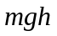 = 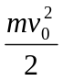 (1)
from which we may solve for v₀ as follows:

V₀ = 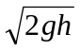 (2)
- Calculation of the vertical component of the velocity at the instant after impact
Let v_{2x} and v_{2y} be the horizontal and vertical components, respectively, of the velocity of the mass center an instant after impact. The height attained in the vertical direction will be αh and then:
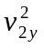 = 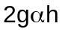 (3)
from which, in terms of α (or the restitution coefficient c = 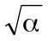):
v_{2y} = 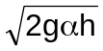 = cv₀ (4)
- General equations for the variations of linear and angular momenta in the time interval of the
Impact
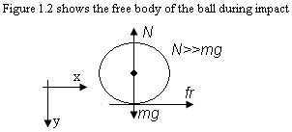
Considering that the linear impulse of the forces is equal to the variation of the linear momentum and that the angular impulse of the torques is equal to the variation of the angular momentum, we have:
I_{y} = 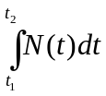 = mv₀ + mv_{2y} = m (1 + c) (5)
I_{x} = 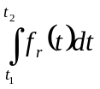 = mv_{2x} (6)
I_{θ} = 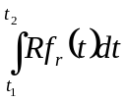= R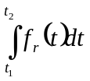 = I (ω_{o} − ω₂) (7)
Where I_{x}, I_{y} and I_{θ} are the linear and angular impulses of the acting forces and ω₂ is the angular velocity after impact. The times t₁ and t₂ correspond to the beginning and end of impact.

Variants
At the beginning of the impact the ball will always be sliding because it has a certain angular velocity ω₀. There are, then, two possibilities:

I. The entire impact takes place without the friction being able to spin the ball enough for it to stop at the contact point and go into pure rolling motion.

II. For a certain time t ∈ (t₁, t₂), the point that comes into contact with the floor has a velocity equal to zero and from that moment the friction is zero. Let us look at each case independently.

Case I
In this variant, during the entire moment of impact, the ball is sliding and the friction relates to the normal force as:
f_{r} = μ _{k}N(t) (8)
Substituting (8) in relations (6) and (7), and using (5), we find that:

I _{x} = μ _{k} = μ _{k}I_{y} = μ _{k} (1 + c ) = mv_{2x} (9)
and:
I_{θ} = R μ _{k} 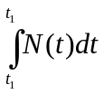 = R μ _{k} m(1 + c) = I(μ ₀ − μ ₂) (10)
which can give us the horizontal component of the velocity v_{2x} and the final angular velocity in the form:
V_{2x} = μ _{k} (1 + c) (11)
ω₂ = ω₀ − 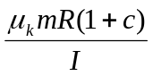 (12)
With this we have all the basic magnitudes in terms of data. The range of validity of the solution under consideration may be obtained from (11) and (12). This solution will be valid whenever at the end of the impact the contact point has a velocity in the direction of the negative x. That is, if:

ω₂R > v_{2x}

ω₀ − > 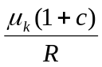

ω₀ > 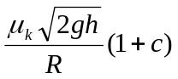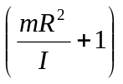 (13)
so, for angular velocities below this value, the solution is not valid.

Case II
In this case, rolling is attained for a time t between the initial time t₁ and the final time t₂ of the impact. Then the following relationship should exist between the horizontal component of the velocity v_{2x} and the final angular velocity:
ω₂R = v_{2x} (14)
Substituting (14) and (6) in (7), we get that:

mRv_{2x} = I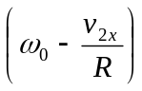 (15)
which can be solved for the final values:
V_{2x} = 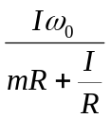 = 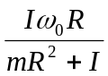 = ω₀R (16)
and:
ω₂ = 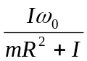 = ω₀ (17)
Calculation of the tangents of the angles

Case I
For tan θ we have, from (4) and (11), that:
tan θ = 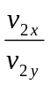 = 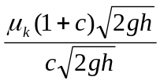 =μ _{k} 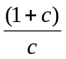
tan θ = μ _{k} (18)
i.e., the angle is independent of ω₀.

Case II
Here (4) and (16) determine for tan θ that:
tan θ = = 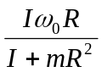 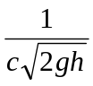 =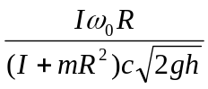
tan θ = 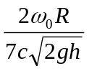 (19)
then (18) and (19) give the solution (fig. 1.3).

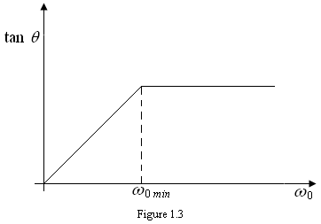

We see that θ does not depend on ω _{o} if ω ₀ > ω _{0 min}; where ω _{0 min} is given as:
ω _{o min} = 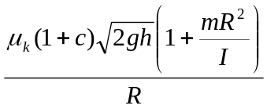
ω _{o min} = 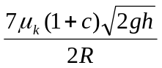 (20)
Calculation of the distance to the second point of impact

Case I
The rising and falling time of the ball is:
t _{v} = 2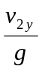 = 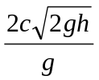 = 2c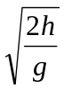 (21)
The distance to be found, then, is;

d_{I} = v_{2x}t_{v} = μ _{k} (1+ c) 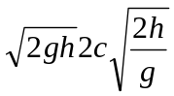
d₁ = 4μ _{k}(1+ c ) ch (22)
which is independent of ω ₀.

Case II
In this case, the rising and falling time of the ball will be the one given in (21). Thus the distance we are trying to find may be calculated by multiplying t_{v} by the velocity v_{2x} so that:

d_{II} = v_{2x}t_{v} = 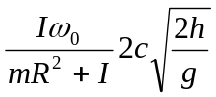 =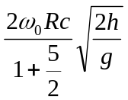
d_{II} = 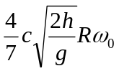
Thus, the distance to the second point of impact of the ball increases linearly with ω ₀.

Marking Code
The point value of each of the sections is:
1.a 2 points
1.b 1.5 points
1.c 2 points

2.a 2 points
2.b 1.5 points
3 1 point

Solution Problem 2
Question a:
Let’s call S the lab (observer) frame of reference associated with the observer that sees the loop moving with velocity v; S’ to the loop frame of reference (the x’ axis of this system will be taken in the same direction as ; y’ in the direction of side DA and z’ axis, perpendicular to the plane of the loop). The axes of S are parallel to those of S’ and the origins of both systems coincide at t = 0.

- Side AB

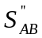 will be a reference frame where the moving balls of side AB are at rest. Its axes are parallel to those of S and 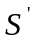. 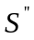has a velocity u with respect to .
According to the Lorentz contraction, the distance a, between adjacent balls of AB, measured in , is:
a_{r} = 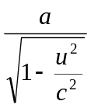 (1)

(This result is valid for the distance between two adjacent balls that are in one of any sides, if a, is
measured in the frame of reference in which they are at rest).

Due to the relativistic sum of velocities, an observer in S sees the balls moving in AB with velocity:
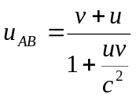 (2)
So, because of Lorentz contraction, this observer will see the following distance between balls:
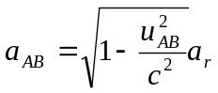 (3)
Substituting (1) and (2) in (3)
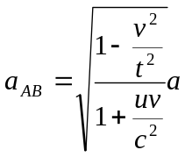 (4)
- Side CD
For the observer in S, the speed of balls in CD is:
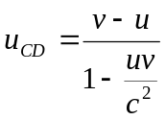 (5)
From the Lorentz contraction:
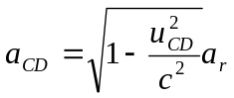 (6)
Substituting (1) and (5) in (6) we obtain:
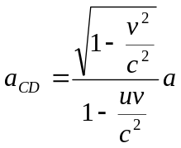 (7)

- Side DA
In system S’, at time , let a ball be at 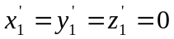. At the same time the nearest neighbour to this ball will be in the position 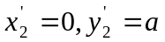, 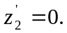
The space-time coordinates of this balls, referred to system S, are given by the Lorentz transformation:
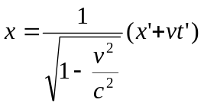
y=y’
z=z’ (8)
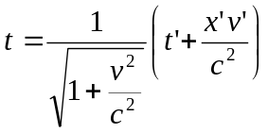
Accordingly, we have for the first ball in S:
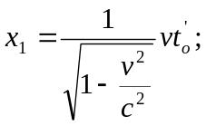 y₁=0; z₁=0; 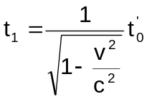 (9) (9)

And for the second:
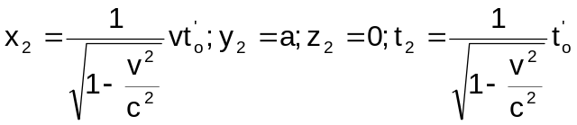 (10)
As t₁= t₂, the distance between two balls in S will be given by:
a_{DA}=(x₂-x₁)² + (y₂ – y₁)² + (z₂-z₁)² (11)
So:
a_{AD}=a (12)
- Side BC
If we repeat the same procedure as above, we can obtain that:
a_{BC}=a
(13)
Question b:
The charge of the wire forming any of the sides, in the frame of reference associated with the loop can be calculated as:
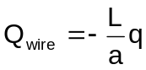 (14)
Because L/a is the number of balls in that side. Due to the fact that the charge in invariant, the same charge can be measured in each side of the wire in the lab (observer) frame of reference.
1. Side AB
The charge corresponding to balls in side AB is, in the lab frame of reference:
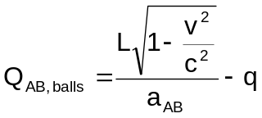 (15)
This is obtained from the multiplication of the number of balls in that side multiplied by the (invariant) charge of one ball. The numerator of the first factor in the right side of equation (15) is the contracted distance measured by the observer and the denominator is the spacing between balls in that side.
Replacing in (15) equation (4), we obtain:
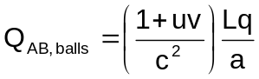 (16)
Adding (14) and (16) we obtain for the total charge of this side:
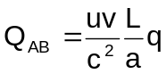 (17)
2. Side CD
Following the same procedure we have that:
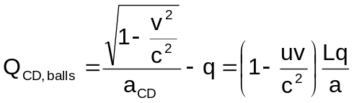 (18)
And adding (14) and (18) we obtain:
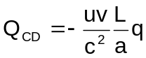 (19)
The length of these sides measured by the observer in S is L and the distance between balls is a, so:
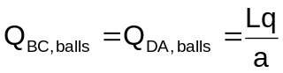 (20)
Adding (14) and (20) we obtain:
Q_{BC} = 0 (21.1)
Q_{DA}=0 (21.2)
Question c:
There is electric force acting into the side AB equal to:
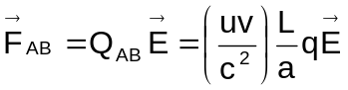 (22)

and the electric force acting into the side CD is:
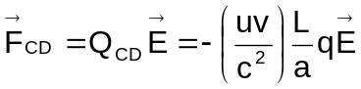 (23)
F_{CD} and F, form a force pair. So, from the expression for the torque for a force pair we have that (fig. 2.2):
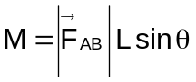 (24)
And finally:
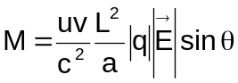 (25)
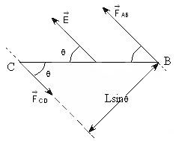
Fig 2.2
Question d:
Let’s call V_{AB and V}CD the electrostatic in the points of sides AB and CD respectively. Then:
W=V_{AB}Q_{AB} + V_{CD}Q_{CD} (26)
Let’s fix cero potential (V=0) in a plane perpendicular to and in an arbitrary distance R from side AB (fig. 2.3).
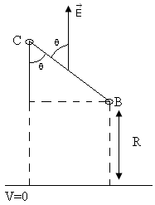
Figure 2.3
Then:
W=-ERQ_{AB} – E(R+Lcosθ)Q_{CD} (27)
But Q_{CD}=-Q_{AB}, so:
W=-ELQ_{AB}cosθ (28)
Substituting (17) in (28) we obtain:
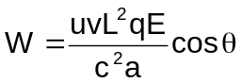 (29)
Marking Code
Grading for questions will be as follows:
a)4,5 points.
b)2,0 points.
c)1,5 points.
d)2,0 points.
These points are distributed in questions in the following way:
Question a:
1. Obtaining expressions (4) and (7) correctly: 3,0 points.
Only one of them correct: 2,0 points.
2. Obtaining expressions (12) and (13) correctly including the necessary calculations to arrive to this results: 1,5 points.
Only one of them correct: 1,0 points.
If the necessary calculations are not present: 0,8 point for both (12) and (13) correct; 0,5 points for only one of them correct.
Question b:
- Obtaining expressions (17) and (19) correctly: 1,0 point.
Only one of them correct: 1,0 point.
2. Obtaining expressions (21.1) and (21.2) correctly: 0,5 point.
Only one them correct: 0,5 point.
Question d:
- Obtaining expression (29) correctly: 2,0 points.
When the modulus of a vector is not present where necessary, the student will loose 0,2 points. When the modulus of q is not present where necessary the student will loose 0,1 points.

Solution Problem 3
Question a:
The velocity v_{o} of the atoms whose kinetic energy is the mean of the atoms on issuing from the collimator is given is given by:
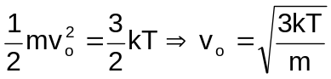 (1)

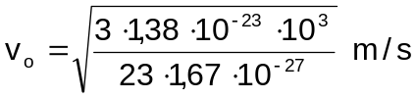
v_{o} ≈ 1,04⋅10³ m/s because:
m ≈ 23 m_{p} (2)
Since this velocity is much smaller than c, v_{o}<< c, we may disregard relativistic effects.
Light is made up of photons with energy hν and momentum hν/c.
In the reference system of the laboratory, the energy and momentum conservation laws applied to the absorption process imply that:
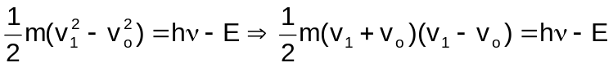
hν/c<<mv_{o}. Then v₁ ≈ v_{o} and this implies mv_{o}Δv₁ = hν = E, where we assume that
v₁ + v_{o} ≈ 2v_{o}
Combining these expressions:
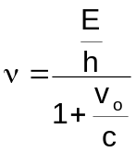 (3)
and:
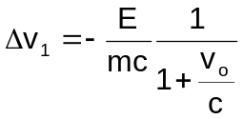 (4)
And substituting the numerical values:
ν ≈ 5,0⋅10¹⁴ Hz Δv₁ ≈ -3,0⋅10⁻² m/s
If we had analyzed the problem in the reference system that moves with regard to the laboratory at a velocity v_{o}, we would have that:
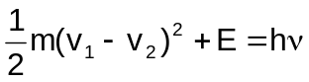
Where 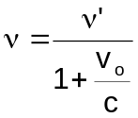 is the frequency of the photons in the laboratory
system. Disregarding 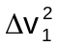 we get the same two equations above.
The approximations are justifiable because:
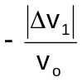 ∼ 10⁻⁴
Then v₁ + v_{o} = 2v_{o} - Δv₁ ≈ 2v_{o}

Question b:
For a fixed ν:
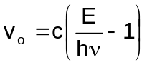 (5)
if E has an uncertainty Γ, v_{o} would have an uncertainty:
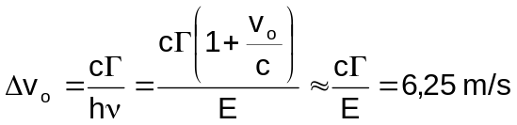 (6)
so the photons are absorbed by the atoms which velocities are in the interval 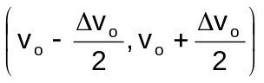
Question c:
The energy and momentum conservation laws imply that:
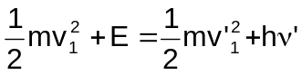
(ν’ – is the frequency of emitted photon)
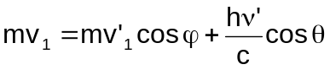
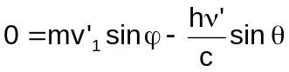
The deviation ϕ of the atom will be greatest when 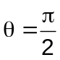, then:
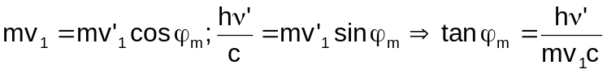
since ν’ ≈ ν:
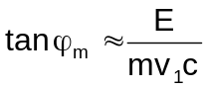 (7)
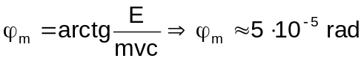 (8)

Question d:
As the velocity of the atoms decreases, the frequency needed for resonant absorption increases according to:
When the velocity is v_{o} = Δv, absorption will still be possible in the lower part of the level if:
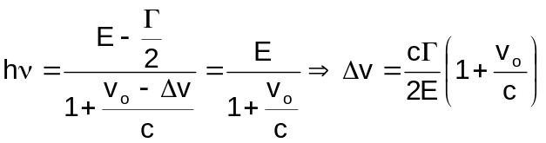 (9)
Δv = 3,12 m/s

Question e:
If each absorption-emission event varies the velocity as 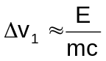, decreasing velocity from v_{o} to almost zero would require N events, where:
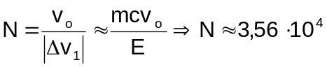

Question f:
If absorption is instantaneous, the elapsed time is determined by the spontaneous emission. The atom remains in the excited state for a certain time, 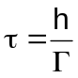, then:
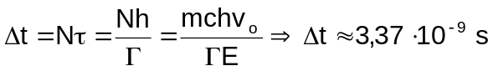
The distance covered in that time is ΔS=v_{o}Δt/2. Assuming that the motion is uniformly slowed down:
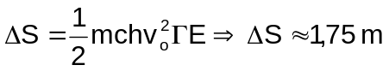

Marking Code
a)Finding v_{o} 1 pt Total 3 pt
“ ν 1 pt
“ Δv₁ 1 pt
b) “ Δv_{o} 1,5 pt Total 1,5 pt
c) “ ϕ_{m} 1,5 pt Total 1,5 pt
d) “ Δv 1 pt Total 1 pt
e) “ N 1 pt Total 1 pt
f) “ Δt 1 pt Total 2 pt
“ ΔS 1 pt ____________
Overall total 10 pts
We suggest in all cases: 0,75 for the formula; 0,25 for the numeral operations.

E X P E R I M E N T A L PR O B L E M

Problem
Inside a black box provided with three terminals labeled A, B and C, there are three electric components of different nature. The components could be any of the following types: batteries, resistors larger then 100 ohm, capacitors larger than 1 microfarad and semiconductor diodes.
a)Determine what types of components are inside the black box and its relative position to terminal A, B and C. Draw the exploring circuits used in the determination, including those used to discard circuits with similar behaviour
b)If a battery was present, determine its electromotive force. Draw the experimental circuit used.
c)If a resistor was present, determine its value. Draw the experimental circuit used.
d)If a capacitor was present, determine its value. Draw the experimental circuit used.
e)If a diode was present, determine V_{o} and V_{r}, where V_{o} the forward bias threshold voltage and V_{r} is the reverse bias breakdown voltage.
f)Estimate, for each measured value, the error limits.

The following equipments and devices are available for your use:
1 back box with three terminals labeled A, B and C;
1 variable DC power supply;
2 Polytest 1 W multimeters;
10 connection cables;
2 patching boards;
1 100 kΩ, 5 % value resistor;
1 10 kΩ, 5 % value resistor;
1 1 kΩ, 5 % value resistor;
1 100 μF, 20 % value capacitor;
1 chronometer;
2 paper sheets;
1 square ruler;
1 interruptor.
Voltmeter internal resistance.
Scale Value in kΩ
0-1 V 3,2 1 %
0-3 V 10 1 %
0-10 V 32 1 %
0-20 V 64 1 %
0-60 V 200 1 %

Ammeter internal resistance.
Scale Value in Ω
0-0,3 mA 1 000 1 %
0-1 mA 263 1 %
0-3 mA 94 1 %
0-20 mA 30,4 1 %
0-30 mA 9,84 1 %
0-100 mA 3,09 1 %
0-300 mA 0,99 1 %
0-1 mA 0,31 1 %

Notice: Do not use the Polystes 1 W as an ohmmeter. Protect your circuit against large currents, and do not use currents larger than 20 mA.

Give your results by means of tables or plots.

When drawing the circuits, use the following symbols:
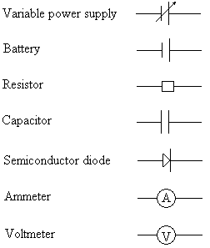

E X P E R I M E N T A L PR O B L E M. S O L U T I O N

Solution Problem
Since a battery could be present, the first test should be intended to detect it. To do that, the voltage drops V_{ab}, V_{ac} and V_{bc} should be measured using a voltmeter. This test will show that no batteries are present.

Next, a testing circuit as shown in figure 4.1 should be used.
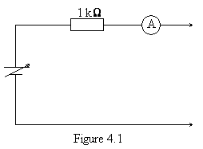
By means of this circuit, the electric conduction between a pair of terminals should be tested, marking all permutations and reversing the polarity. Resistor R₁ is included to prevent a large current across the diode. One conclusion is that between A and C there is a diode and a resistor in series, although its current position is still unknown. The other conclusion is that a capacitor is tighted to terminal B. To determine the actual circuit topology, further transient experiments have to be conducted.

In this way, it is concluded that the actual circuit inside the black box is that shown in figure 4.2.
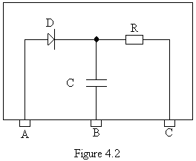
The best procedure for the resistor value determination is to plot a set of voltage and current values measured between A and C. Figure 4.3 shows the resulting plot. Extrapolating both linear regions, the values of V_{o} and V_{z} are obtained and the resistor value equals the reciprocal of the slope.

Similar, the best method to measure the capacitor value is to build a testing circuit as shown in figure 4.4. The current is adjusted to full scale and then, the switch is opened.

The time needed by the current to drop to its half value is measured. Applying the formulae t = RCIn(2), the value of C is obtained.
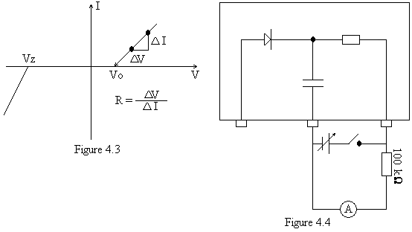
Marking Code
1. Determination of circuit topology: 8 points.
1.1 For discarding the presence of a battery: 1 point.
1.2 For drawing the exploring circuit which determine the circuit topology in a unique way: 7 points.
2. Resistor and diode parameters value measurement: 8 points.
2.1 For drawing the measuring circuit: 2 points.
2.2 Error limits calculation: 3 points.
2.3 Result: 3 points.
2.3.1 Coarse method: 2 points.
2.3.2 Graphic method: 3 points.
3. Capacitor value measurement: 4 points.
3.1 For drawing the measuring circuit: 2 points.
3.2 Error limits calculations: 2 points.

